**Q1**

An image on a webpage that has clickable areas on it is known as an “Image Map”. The <map> tag is used to define an image map. The required name attribute of the <map> element is associated with the [<img>](https://www.w3schools.com/tags/tag_img.asp)'s use map attribute and creates a relationship between the image and the map. The map contains clickable areas that are defined by the <area> tag.

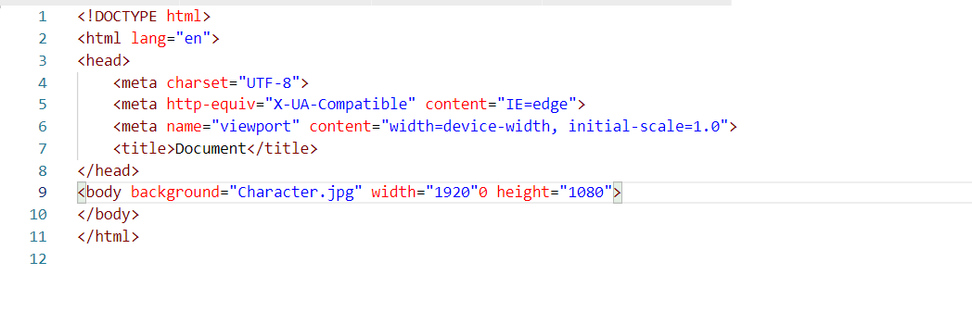

**Q2**

Categories of HTML5 and HTML4 are as follow:

1. Singular Tags.
2. Paired Tags.
3. Meta tags.
4. Page Structure Tags.
5. Formatting Tags.
6. Interactive Tags.
7. Control Tags.

**Q3**

Following are some difference between HTML and XHTML:

1. HTML is an acronym Hypertext Markup Language. XHTML is an acronym Extensible Hypertext Markup Language.
2. HTML is used to create webpages. XHTML is formulated from HTML.
3. HTML is generated from SGL. Whereas, XHTML is generated from HTML.
4. Nest Tags are not used in HTML. Whereas, Nest tags are used in XHTML.
5. HTML is not case sensitive. XHTML is extremely case-sensitive.
6. HTML codes can either be written in uppercase or lowercase. Whereas, codes can only use lower case.
7. HTML doesn’t have strict rules to follow. Whereas, XHTML has strict measures to follow.

**Q4**

{Uploaded on Github as Assignment 1}